BE-GY 6513 Modular Adherent Insulin Pump System
Yolander Adjei, Dhruv Tyagi, Abhiramalakshmi Senthil Kumar, Supreeth Sai Krishna
NYU Tandon School of Engineering
Biomedical Engineering, MS
Abstract
Diabetes is one of the most prominent diseases in the human populace in the 21st century and this paper addresses the growing global concern for diabetes along with the escalating economic burden imposed by it by proposing a novel design for an adherent insulin pump system. Diabetes rates are continuing to skyrocket, reaching 532 million people in 2023, necessitating innovative solutions to improve patient outcomes and alleviate the economic strain. Current insulin therapy methods, including pens and injections, face limitations such as disintegrated designs hindering mobility and discomfort from tethering connections. Our proposed design draws inspiration from existing models but introduces a seamlessly integrated, modular, and adherent insulin pump system. The design uses a non-invasive optical sensor and substitutes infusion set cannulas with microneedles.The paper details the rationale behind the material selection, choosing polylactic acid (PLA) for the chassis and thermoplastic polyurethane (TPU) for the adhesive base. The manufacturing process involves 3D printing with Ultimaker 3 for rapid prototyping, showcasing the feasibility and cost-effectiveness of the proposed design. The final prototype demonstrates a sleek, user-friendly insulin pump with potential applications in diabetes management.
Keywords
insulin, glucose, sensor, cannula, monitoring
Overall Reason for the Selection / Highlights
Motivated by the Medtronic 780G insulin model, our integrated design seeks to improve patient mobility while eliminating the need for clothing support. It eliminates the push buttons, features a touchscreen functionality and innovative screen flap and considers the exchange of the cannula-designed continuous glucose monitoring CGM sensor with an optical version.
Introduction
Diabetes is a chronic metabolic condition characterized by consistently elevated levels of glucose (sugar) in the bloodstream. This elevation results from either insufficient production of insulin by the pancreas, the body's resistance to insulin's action, or a combination of both factors (Zimmet et al., 2014). Insulin, a hormone naturally produced by the pancreas, serves a critical role in regulating blood sugar levels by facilitating the uptake of glucose into cells. Individuals with diabetes experience persistent high blood sugar levels and can have complications that often affect multiple organs and systems in the body, including the eyes, kidneys, nerves, and cardiovascular system (Harati, 1996) (Lutty, 2013). The treatment of diabetes is a multi-billion dollar industry that spans the globe in terms of design, manufacturing, servicing, and healthcare.

Scientific Impact
Data from 2019 showed that 463 million people between the ages of 20 and 79 suffered from diabetes worldwide. By 2045, the number of diabetic individuals in this age group is projected to increase to 700.1 million (Buchholz, 2021). Estimates show that the global economic burden of diabetes may rise from $1.3 trillion in 2015 to $2.2 trillion by 2030. Insulin pens and injections require the consistent monitoring of the patient’s blood and are highly prone to poor results due to inconsistent monitoring. Insulin pens use prepared concentrations of insulin and give a more regulated dose but are more expensive. Insulin pumps provide a more precise and personalized approach to delivering insulin therapy by delivering insulin through a thin catheter inserted into the subcutaneous tissue, mimicking the body's natural insulin production (Lenhard and Reeves, 2001). Insulin pumps deliver insulin in small, incremental automated doses, allowing for more precise control of blood sugar levels reducing the risk of hypoglycemia and hyperglycemia.

Current Market for Insulin Pumps
As of 2022, the global market for insulin pumps is estimated to have a value of US$ 6.18 billion. Forecasts predict an upward trajectory, with worldwide sales projected to surge at a Compound Annual Growth Rate (CAGR) of 8%, reaching a market valuation of US$ 13.34 billion by the culmination of 2032. The demand for patch pumps is anticipated to exhibit even faster growth, expected to soar at a CAGR of 10% from 2022 to 2032 (Jha, 2022). As of 2022, North America leads the insulin pump market with a revenue share of approximately 45.8%. The current leading firms in the current market are Debiotech S.A, Tandem Diabetes Care Inc., Medtronic PLC, Insulet Corp, F. Hoffman-La Roche Ltd. Medtronic is the leader in the insulin pump market within the DME channel (Knebel and Neumiller, 2019), however, Tandem Diabetes Care and Insulet are steadily gaining ground, having a combined market share of nearly 50% in 2022.

Previous Development
Over the evolution of Medtronic's insulin pump systems, advancements have been substantial. The transition from the MiniMed 670G to the MiniMed 770G brought about improved algorithms, extended-wear sensors, and wireless connectivity, enhancing precision in insulin delivery and user convenience. The latest MiniMed 780G represents a significant improvement, introducing algorithms for heightened precision, meal-detection technology with auto correction boluses, adjustable glycemic targets, and practical features such as the Guardian 4 sensor and extended-wear infusion set.

Critical Gaps
Within tether MiniMeds, limitations exist in terms of mobility, discreet use in public, and attachment issues due to fabric constraints. External temperature variations pose risks to its functionality. Both the infusion set and CGM involve cannulas, necessitating dual skin tissue insertions. Accidental blood vessel punctures may cause minor bleeding and discomfort. Prolonged use of the same and multiple insertion sites may lead to localized fatty tissue buildup, reducing insulin absorption efficiency.

Methods
Design Scheme: The innovative layout of the Medtronic MiniMed 780G closed-loop insulin pump served as the model for our modular-adherent insulin pump system. We plan on the integration of all the component parts to create a modular device with an adhesive base, a shielding flap that houses the display, and an adhesive base. The design further highlights the need for a non-intrusive optical CGM sensor and infusion microneedle. The purpose of this setup is to overcome the shortcomings of the fragmented design and improve efficiency, convenience, and satisfaction for users.
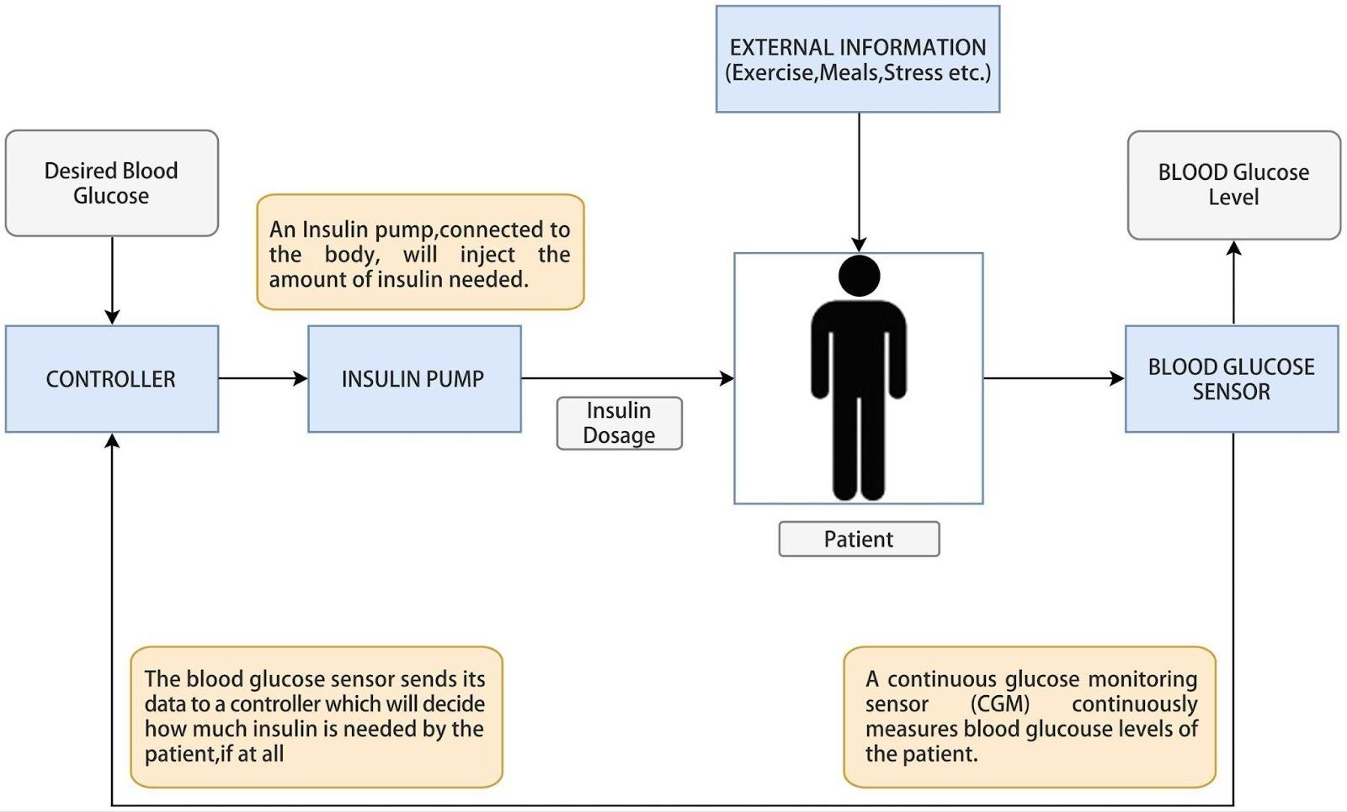
Figure: System Architecture Diagram.(Kapil et al., 2020)
Material Selection: Polylactic acid (PLA) was selected for rapid prototyping due its accessibility, biocompatibility, lower melting temperature for quick prototyping, affordability, and color alternatives for visual distinction. While silicone adhesives are taken into consideration for the adhesive base, thermoplastic polyurethane (TPU) is chosen due to its high bonding capacity to various substrates, mobility, and chemical resistance. These choices are made based on selecting biomaterials that can withstand extended skin contact, have good structural integrity and durability needed for all parts of the device.
Manufacturing Technology: Originally intended for molding by injection, the prototype is to be fabricated via material addition rapid prototyping with Ultimaker 3 3D printers. Autodesk Fusion 360 is utilized for designing and Cura software is used for slicing. The selected technical settings considered are 40% infill density, triangle infill pattern, and two nozzles made of separate materials (TPU for the adhesive base and PLA for the chassis). The last stage of assembly consists of straightforward connecting procedures.

Results and Discussion
6.1 Design Scheme (Medtronic Minimed 780G Inspiration)
The overall design configuration of this adherent insulin pump system takes inspiration from the Mini-Med 780G insulin pump design. It comprises a continuous glucose monitoring sensor (CGM) for blood glucose monitoring, an infusion pump or reservoir that stores and delivers the insulin, and an infusion set that discreetly delivers the insulin through a flexible tube to the blood through the skin. It has embedded safety features that permit automated suspension of delivery on occasions where the algorithm predicts a potential drop in blood glucose levels. The integrated wireless connectivity empowers patients to manage and share data more seamlessly when accessing glucose data and system status on compatible mobile devices.

Design Restrictions: Due to the disintegrated design of the mini-med model, all the parts of the system work in a closed-loop configuration with flexible tubings and wireless connectivity causing the linkage. There may be limitations to mobility and ease of access. It also poses a challenge to making adjustments or administering boluses discreetly in public situations. Sport activities increase the risk of accidental dislodgement causing the pump to detach from clothing and some fabric types may not support the weight of the device making this a limiting option for some users. Temperature sensitivity is another concern due to insulin pumps being sensitive to extreme external temperature variations. Both the infusion set and CGM utilize cannulas in their operations, indicating two points of insertion into the skin tissues. If blood vessels are punctured while insertion, minor bleeding and discomfort may be experienced. Continuous use of the same insertion sites may lead to lipohypertrophy.

Proposed Design and Benefit: Our design suggests the integration of all the parts of the insulin system into an embedded modular body-adherent unit with an adhesive base and a flap encasing a touchscreen control system. For further innovation enhancement, a non-invasive optical CGM is used in place of the cannula-designed cgm and a microneedle is used in place of the infusion set cannula. The integration concept allows enhanced functionality of the closed-loop configuration. As a single modular device, there is increased ease of access, improved user mobility and ease of detachment and part replacement. The flap provides an extra layer of protection to the new touch screen control against dust, accidental touch inputs and sweat, useful during periods of inactivity, shielding the screen light from being visible under clothes. The use of the optical cgm sensor allows non-invasive glucose monitoring eliminating the use and frequent replacement of cannulas, eliminating user discomfort from skin penetrations. The optical sensor will not require the need for frequent site rotation in lipohypertrophy prevention.A swap for microneedles instead of the infusion set cannula was considered, as hollow microneedle technology has been proven to be efficient in systemic as well as local delivery of other macromolecular drugs, such as vaccines(ref).

QFD Chart
Customer requirements were finalized from a study to assess patient satisfaction of the MiniMed 670G insulin pump. Those participants' views obtained provided insight on the automatic feature (ref). Based on our QFD analysis, the highest customer requirement needed to be met is ease of mobility, while reduced invasiveness of the device and active lifestyle maintenance follow closely hence informing our design scheme. The technical requirements that we plan to focus on are durability, infusion delivery, protective cover, non-irritant material, dimension, and lightweightedness with the highest priority being durability.
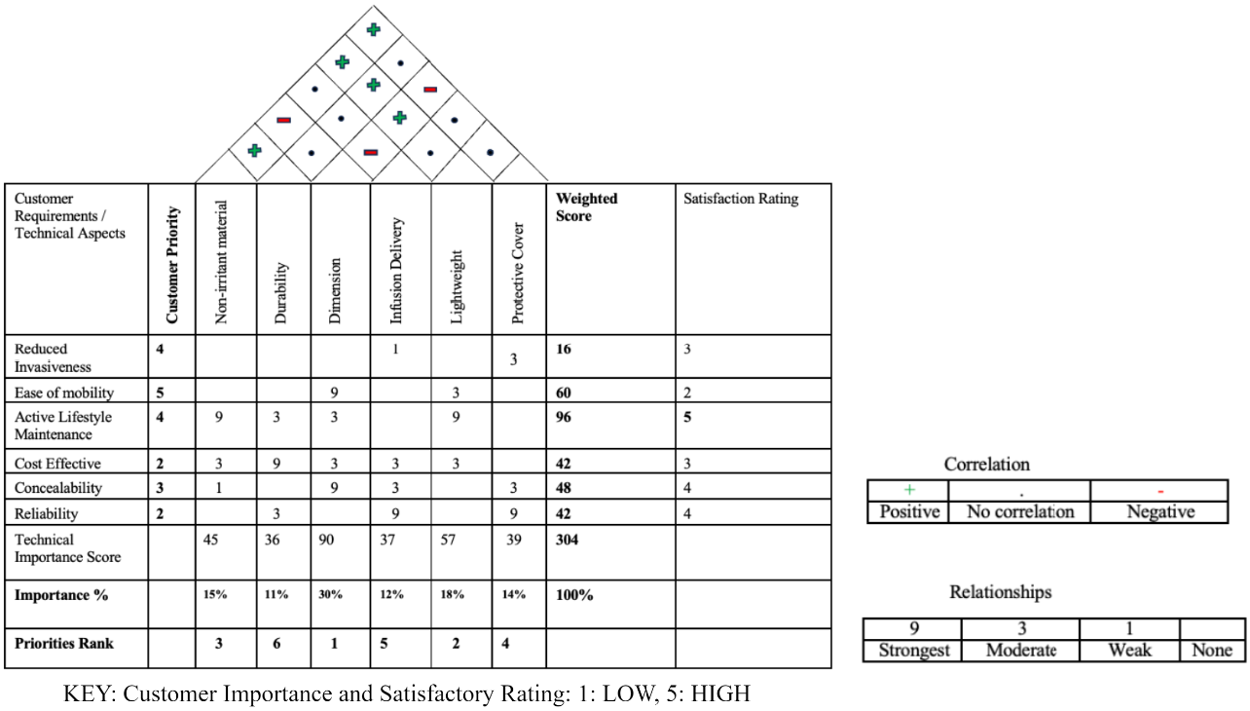
Material Selection
System Chassis: For our adherent insulin pump system, thermoplastic elastomer (TPE) material is initially considered as TPE has a wide range of applications for biomedical devices that come into direct contact with the human skin, flexibility, soft-touch tactile features, electrical insulation, excellent chemical resistance and bonding abilities. However due to restrictions in availability, polylactic acid (PLA) material is finally selected for manufacturing suitability and rapid prototyping. As a biocompatible biodegradable material with a lower melting point as compared to other materials, PLA is suitable for iterative design processes. It offers a smooth surface finish reducing post processing techniques, highly cost-effective and affordable, beneficial for the various iterations made during the development cycle. PLA has good strength and rigidity creating a steady prototype for encasing the CGM sensor, infusion reservoir, and other electrical components ensuring stability and minimal shifting of components that could alter glucose measurements and insulin delivery. Due to its availability in various colors, PLA aids the visualization and differentiation of the various fabricated parts.

Adhesive Base: For the device to adhere to human skin without failure, a material that offers good adherent properties, biocompatibility, minimal irritation to users, and strong enough to bear the entire weight of the prototype is needed. Silicone adhesives are considered for their flexibility, elasticity, electrically insulating properties, shock absorbency and wide temperature tolerance. For the purpose of our design, thermoplastic polyurethane TPU material is selected as a representation of the adhesive base as it mimics the high flexibility, elasticity and chemical resistance to various solvents of the silicone adhesive. It has great bonding strength to multiple substrates, such as our PLA-manufactured chassis, providing a durable connection and good shock absorption qualities. TPU can form films on its surface hence formulation of an adhesive-like layer can be made to offer adherent properties to the user’s skin. Due to its availability in multiple filaments, clear TPU enables visibility and optical clarity to the base of the device, allowing the functionality of the optical CGM sensor.

Manufacturing Technologies
Injection molding is the initial consideration for fabrication of the biomedical device prototype. This process, which is effective for mass production of items with intricate details, allows the injection of molten polymer into mold-like cavities and further cooled to solidify. Due to limitations and time constraints, the fabrication process involved material addition rapid prototyping with Ultimaker 3 3D printers.
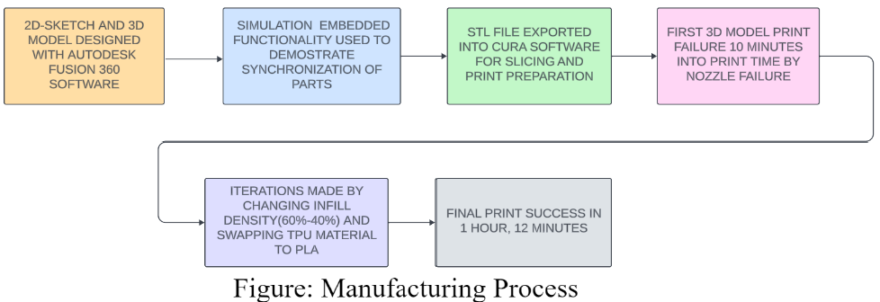

3D Model Design
Autodesk Fusion 360 is the software used for modeling the initial design. The dimensions for the entire hollow system chassis was 54mm for length, 35mm for width and height of 15mm to obtain a small-dimensioned product as required by the QFD analysis. The hollow was created with a 6mm thickness offset from the edge of the body. The space reserved for visualization of the touchscreen functionality including the flap both had dimensions of 29mm by 37.7mm. The notch of the flap was about 3mm thick and rounded for better finger grip. The adhesive base was designed to be 35mm wide, 37.5mm long, with one-end rounded sides of radius 12.5mm. Surface appearance edits, such as LCD color to mimic the touch screen, were employed for better visualization. The simulation functionality embedded in Autodesk was utilized to show the synchronization of the part assembly in an approximately 30 second video. The entire model was dismembered and transferred as stl files to the Ultimaker Cura software for further processing.

Cura Software and Ultimaker 3 Printer Utilization: To prepare the individual files for printing, the parts needed to be sliced to estimate print time and to determine final print outlook. The technical settings used were 60% infill density (which was later changed to 40%), triangle infill due to its strong infill pattern over the other shapes and great structure, nozzle 1 with pink polylactic acid PLA material for the chassis, and nozzle 2 with clear-coloured thermoplastic polyurethane TPU material for the adhesive base. The total weight was approximately 26g. After slicing, the estimated print time was 2 hours and 1 minute.
Assembly: After printing and cooling processes, all successful prints were assembled with simple joining processes without adhesives due to exhibition and presentation processes. The flap perfectly fit into the depression created. However under ideal conditions, adhesive bonding was considered for attachment of base to chassis.
Prototype Failures: The first print failure occurred about 10 minutes into print time due to nozzle failure of the Ultimaker 3 Lamarr as a result of workload due to high precision printing of infill density 60% with two different material types (TPU and PLA) in both nozzles. Iterations were made on Cura by changing infill density 40% to reduce workload and swapping clear TPU material for adhesive base for clear PLA material for presentation purposes.
Final Design: Final design obtained was finally satisfactory. A sleek and soft-edge pink colored prototype 54mm long, 35mm wide and 15mm was produced accompanied with a clear adhesive base print.
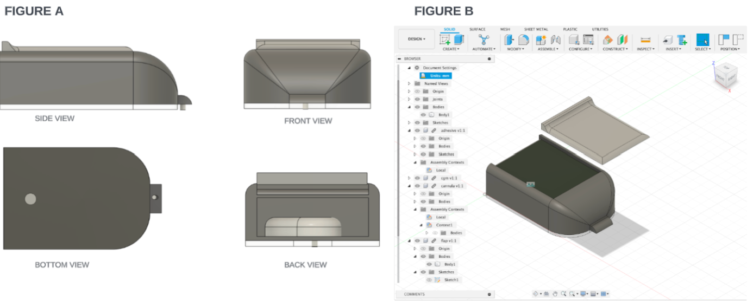
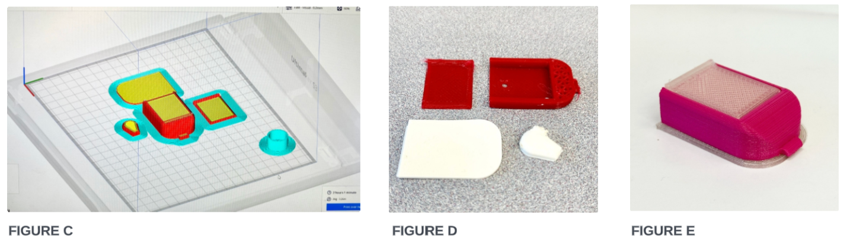
Figure : A. 2D perspective views of dimensional design from Autodesk Fusion 360 featuring dimensions. B. 3D model showing flap orientation. C. Slicing and pre-print editing process with Ultimaker Cura software D. TPU print failure showing unfinished transverse section of chassis. E. Final satisfactory 3D model print showing device chassis on adhesive base.

Conclusions and Future Considerations
Our presented modular-adherent insulin pump is a pioneering biomedical device with an aim of revolutionizing diabetes management. Insulin pumps are one of the most vital therapeutic devices in diabetes treatment, offering a personalized and automated approach, leading to improved glycemic control in thousands of diabetics and usually preferred over traditional insulin pens and injections. This biomedical device allows incremental and automated delivery which minimizes the risk of hypoglycemia and hyperglycemia improving patient outcomes, alleviation of patient burden and fostering better adherence to therapy. Existing devices face drawbacks like disintegrated designs hindering mobility and increasing discomfort from all the tethering connections. Invasiveness indicated by two different insertion points from the CGM sensor and infusion sets of most insulin pumps could also cause lipohypertrophy necessitating future design iterations.
Future designs of insulin pumps are most likely to concentrate on addressing current limitations, user experience enhancement, and incorporating advanced technologies. Some potential that could characterize insulin pump designs in the future include integration with Artificial Intelligence (AI) smart dosing technologies that could analyze real-time data from the CGM dose optimization and miniaturization into wearable fitness devices for even more discreet and lifestyle-friendly solutions. Recent feasibility studies on biosensor integration (Breton et al.) indicated that the integration of a heart rate monitor into a wireless closed-loop system could be made although their exercise algorithm did not show a significant reduction in hypoglycemic events (ref). Further studies are needed on microneedle research. Even though current research suggests microneedles are good substitutes for controllable insulin delivery, further research could target the investigation of microneedle devices with regards to biocompatibility and adjusted flow rates (ref).

References:
- Zimmet, P.Z., Magliano, D.J., Herman, W.H. and Shaw, J.E., 2014. Diabetes: a 21st century challenge. The lancet Diabetes & endocrinology, 2(1), pp.56-64.
- Harati, Y., 1996. Diabetes and the nervous system. Endocrinology and metabolism clinics of North America, 25(2), pp.325-359.
- Lutty, G.A., 2013. Effects of diabetes on the eye. Investigative ophthalmology & visual science, 54(14), pp.ORSF81-ORSF87.
- Roussel, R., Travert, F., Pasquet, B., Wilson, P.W., Smith, S.C., Goto, S., Ravaud, P., Marre, M., Porath, A., Bhatt, D.L. and Steg, P.G., 2010. Metformin use and mortality among patients with diabetes and atherothrombosis. Archives of internal medicine, 170(21), pp.1892-1899.
- Katharina Buchholz,, 2021. Where Diabetes Burders Are Rising. https://www.statista.com/chart/23491/share-of-adults-with-diabetes-world-region/
- Lang, R. 2021, All About Type 2 Diabetes: What Causes it and Can You Reverse It?.
- Vashist, S.K., Zheng, D., Al-Rubeaan, K., Luong, J.H. and Sheu, F.S., 2011. Technology behind commercial devices for blood glucose monitoring in diabetes management: A review. Analytica chimica acta, 703(2), pp.124-136.
- Jha S.N, 2022. Insulin Pumps Markt by Type (Tethered Pumps, Patch Pumps), By Accessory (Infuson Set Insertion Devices, Insulin Reservoirs / Cartridges, Batteries), By End User (Laboratories, Homecare) & By Region - Global Market Insights 2022-2032. FactMR, 2022
- Insulin Pump Market Size, Share & Trends Analysis Report, By Type (Patch, Tethered), By Accessories (Insulin Reservoir Or Cartridges, Insulin Set Insertion Devices, Battery), By End-use, By Region, And Segment Forecasts, 2023 – 2030, Grand View Research. https://www.grandviewresearch.com/industry-analysis/insulin-pump-market#:~:text=:Product%20Insights,rate%20and%20advancement%20in%20technology.
- Knebel, T. and Neumiller, J.J., 2019. Medtronic MiniMed 670G hybrid closed-loop system. Clinical Diabetes, 37(1), pp.94-95.
- Lenhard, M.J. and Reeves, G.D., 2001. Continuous subcutaneous insulin infusion: a comprehensive review of insulin pump therapy. Archives of Internal Medicine, 161(19), pp.2293-2300.
- Kapil, S., Saini, R., Wangnoo, S. and Dhir, S., 2020. Artificial pancreas system for type 1 diabetes—challenges and advancements. Exploratory Research and Hypothesis in Medicine, 5(3), pp.110-120.
- Omnipod 5- https://www.omnipod.com/hcp/products/omnipod5
- Carlson, A.L. et al. 97-P- Safety and glycaemic outcomes of the MiniMed™AHCL System in subjects with T1D. 80th ADA International Conference, June 2020, Chicago
- Collyns .O. et al. 199-OR- Improved glycaemic Outcomes with MiniMed™ AHCL Delivery. 80th ADA International Conference, June 2020, Chicago
- Grando MA, Bayuk M, Karway G, Corrette K, Groat D, Cook CB, Thompson B. Patient Perception and Satisfaction With Insulin Pump System: Pilot User Experience Survey. J Diabetes Sci Technol. 2019 Nov;13(6):1142-1148. doi: 10.1177/1932296819843146. Epub 2019 May 5. PMID: 31055947; PMCID: PMC6835185.
- Grando MA, Bayuk M, Karway G, Corrette K, Groat D, Cook CB, Thompson B. Patient Perception and Satisfaction With Insulin Pump System: Pilot User Experience Survey. J Diabetes Sci Technol. 2019 Nov;13(6):1142-1148. doi: 10.1177/1932296819843146. Epub 2019 May 5. PMID: 31055947; PMCID: PMC6835185.
- DeBoer MD, Cherñavvsky DR, Topchyan K, Kovatchev BP, Francis GL, Breton MD. Heart rate informed artificial pancreas system enhances glycemic control during exercise in adolescents with T1D. Pediatr Diabetes. 2017 Nov;18(7):540-546. doi: 10.1111/pedi.12454. Epub 2016 Oct 13. PMID: 27734563.
- Hultström M, Roxhed N, Nordquist L. Intradermal Insulin Delivery: A Promising Future for Diabetes Management. Journal of Diabetes Science and Technology. 2014;8(3):453-457. doi:10.1177/1932296814530060

